 Pegasys
[Setting Up Favorites]

- The Favorites function in Pegasys is a very useful tool because it allows the user to bookmark their most commonly used data elements. In this example, we will explore the Accounting Templates favorites, but this feature is available wherever the “” is located.

Figure 1
Figure 1
Click the Favorite Icon
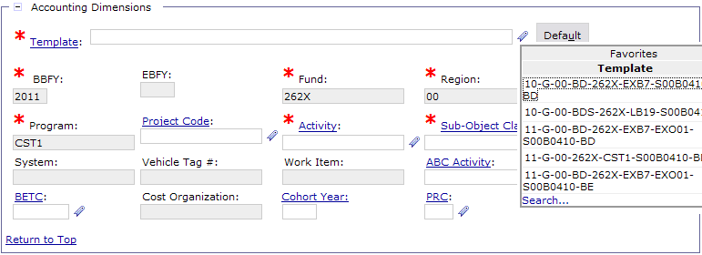
Click Search
- Navigate to the Header Accounting Lines tab on the top toolbar (below breadcrumbs track).
- Click Add.
- Scroll down to the Accounting Dimensions section.
- Click on the Favorites Icon “”, next to the Default command button. (Step 1)
- Click Search in the list box. (Step 2)

Figure 2

- In the subsection Search Criteria, type in the Template Name with the appropriate asterisks before and after the name. (Step 1)
- Click Search. (Step 2)
- When the search results are returned, click on the Favorites Icon “” to add that accounting template to your favorites. (Step 3)
- After adding all the data elements to your favorites, click Select on the accounting template that you wish to use for this transaction. (Step 4)
Figure 2
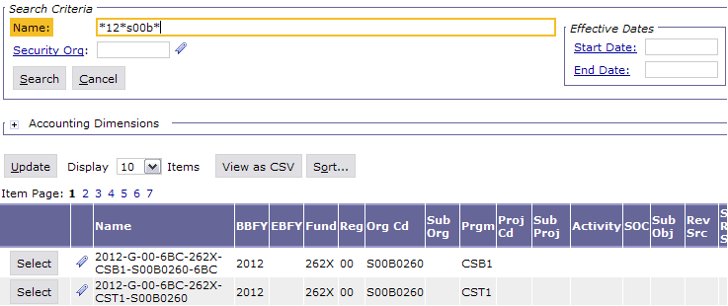
Type in Accounting Template Code
Click Search
Click Add to Favorites
Click Select

(OVER)

Figure 3

Figure 3
- The accounting template that you have selected will populate in the Template Dialog Box.
11) To view the favorites you have selected previously, click the
Favorites Icon once again and a list box will display the newly added favorites.
12) To activate an accounting template from the list on your favorites
- Click the Favorites Icon
- Select the item to be used
- Click the ‘Default’ button.
13) To remove a favorite, click the trashcan to the right of the data element in the list box.
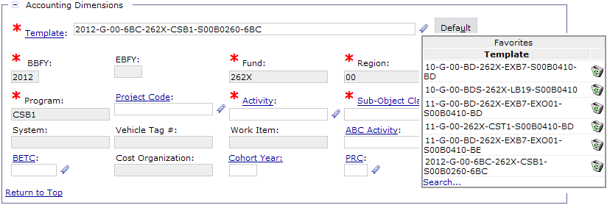
Selected Accounting Template
Accounting Template added to Favorites

